**MiPeople – HR and Screening Solution**

User Manual (Admin/HR Side)

**Table of Contents**

**1.** **Signup** 3

**2.** **Login** 4

**3.** **My Profile** 6

**4.1.** **Recruitment: Vacancy** 8

**4.2.** **Recruitment: Test Question** 11

**4.3.** **Recruitment: Test Template** 12

**4.4.** **Recruitment Flow: New Candidate** 13

**4.5.** **Recruitment: Accept Resume from Each Candidate** 14

**4.6.** **Recruitment: Shortlist Candidate** 15

**4.7.** **Recruitment: Email Test to Candidate** 16

**4.8.** **Recruitment: Schedule Interview** 17

**4.9.** **Recruitment: Send Offer Letter** 18

**4.10.** **Recruitment: Feedback Question** 19

**4.11.** **Recruitment: Feedback Form** 20

## **Signup**

Step by step guide to get registered as a company user on **MiPeople – HR and Screening Solution.**

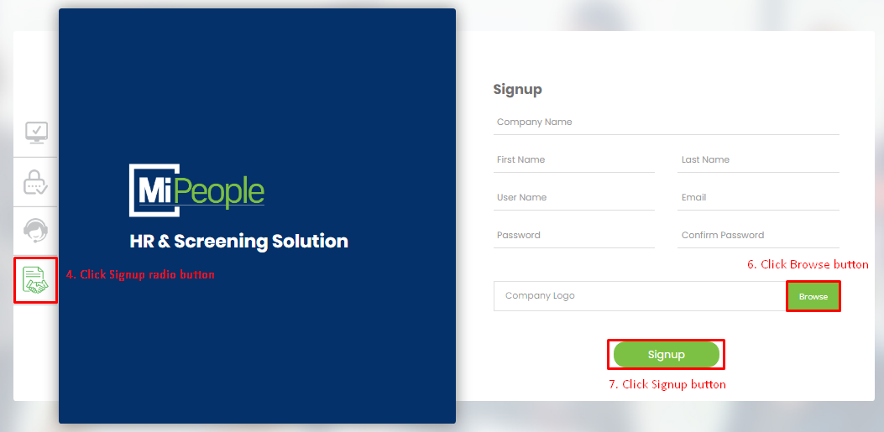

Image 1: Signup Form

1. Open internet browser on your PC (Chrome/Firefox/Safari etc.).
2. Go to the link: <https://app.mipeople.co/login/user_login>.
3. On the opening of above link, you will be directed to Login screen having four radio buttons for Login, Support, Contact and Signup.
4. Click the last radio button for **Signup**, so that you are directed to Signup form.
5. After signup form is shown, carefully fill the form with correct information regarding your company name, your first and last name, the username you wish to register your ID with, your email ID and password.
6. Now upload the picture of logo of the company you are working with.
   1. Click **Browse**.
   2. Go to the location on your PC, where your company logo picture is saved and chose the logo picture.
   3. Click Open button.
7. Click **Signup** button, a popup containing message “Registered Successfully” will appear.

## **Login**

Step by step guide to login to **MiPeople – HR and Screening Solution** using your credentials.

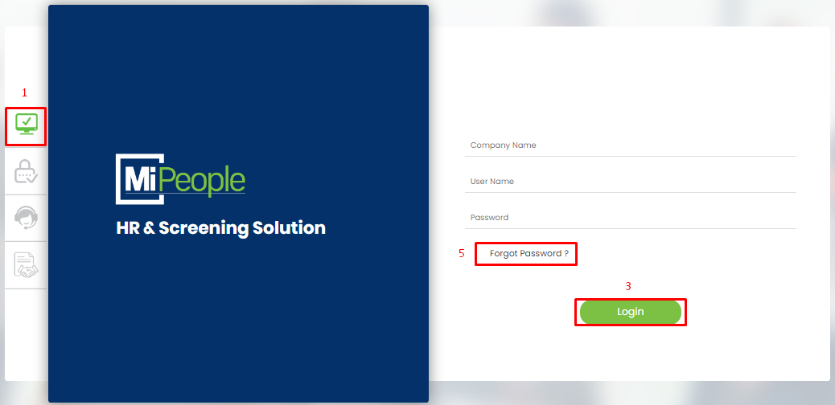

Image 2: Login Form

1. To login to your company account on MiPeople, click on the first radio button i.e. **Login**.
2. Login form will appear, fill out the form with your credentials; company name, username and password.
3. Click **Login**, a popup containing message “Logged in Successfully” will appear and you will be directed to the homepage of your MiPeople account.
4. If you have entered everything correctly, you will be logged in to your MiPeople account. But, if you have entered:
   1. Wrong Company Name, it will fail in logging you in to your MiPeople account and display a popup containing message: Invalid Company Name, Username or Password.
   2. Wrong Username, it will fail in logging you in to your MiPeople account and display a popup containing message: Invalid Company Name, Username or Password.
   3. Wrong Password, it will fail in logging you in to your MiPeople account and display a popup containing message: Invalid Company Name, Username or Password.
5. If you have forgotten your password, you can recover it by simply clicking on “Forgot Password?”.
   1. Click “Forgot Password?”.
   2. Provide the information regarding your Company Name and Email that you registered during the Signup process.
   3. Click Submit button.

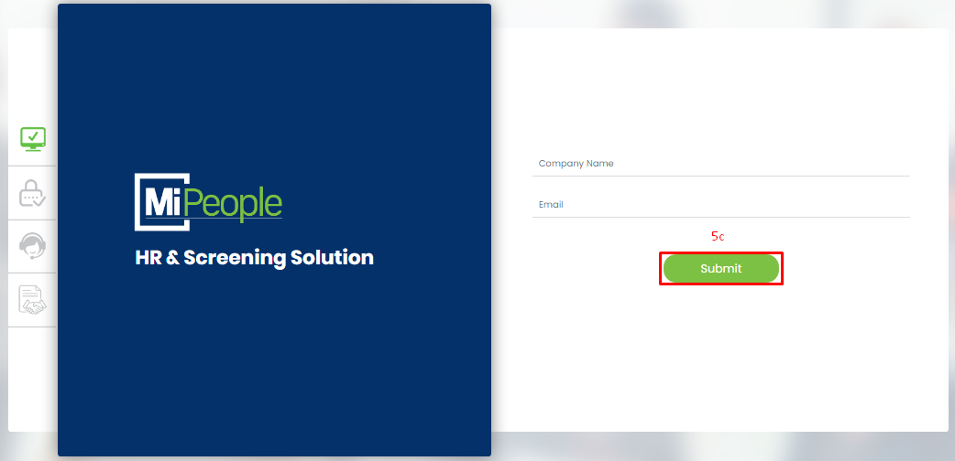

Image 3: Forgot Password

1. If you don’t want to write everything, every time you log in to MiPeople:
   1. Provide your credentials; Company Name, Username and Password, on the login form.
   2. Enable or tick (**✓**) the check box of “Remember me” before clicking Login button.

## **My Profile**

If you want to update your personal information, then:

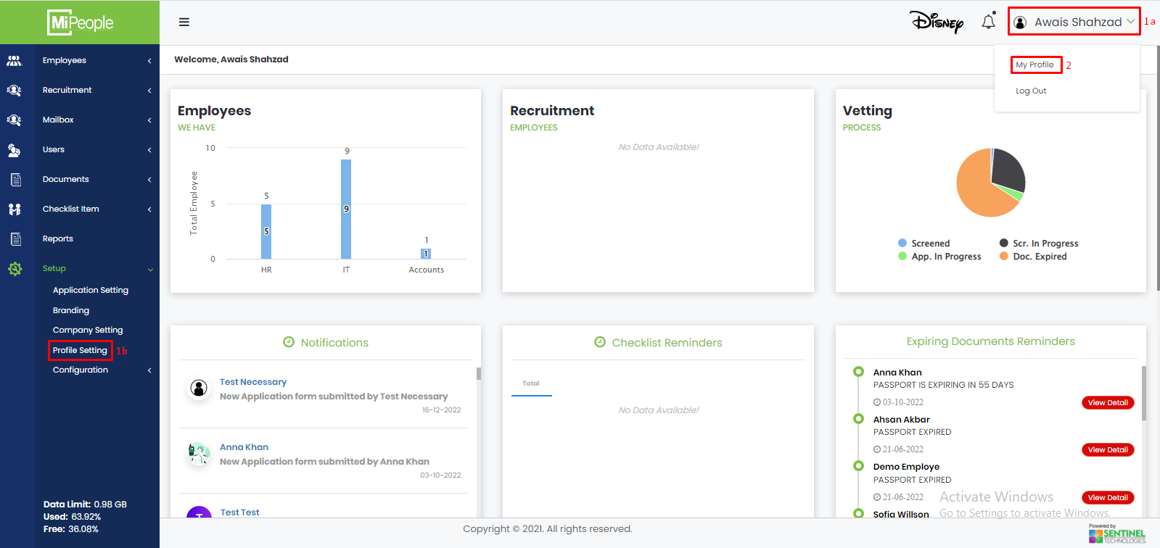

Image 4: My Profile

1a. Click your name being displayed at to right corner of your home screen, so that the drop down menu can appear.

Or

1b. Go to side menu at your home screen, click Setup to open its drop down menu and then click Profile Setting.

1. Click My Profile.
2. Update your information by carefully filling/editing the text fields.

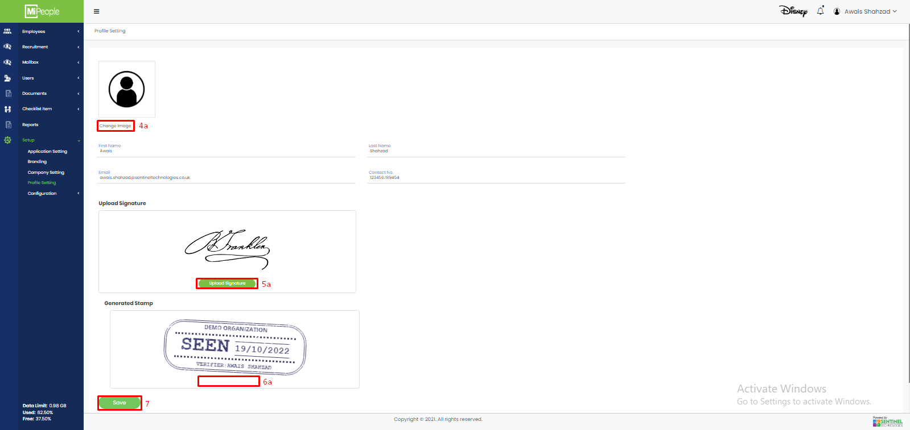

1. Upload your profile picture:
   1. Click Change Image button.
   2. Select the image you want to set as your profile photo.
   3. Click Open button, selected image will be uploaded.
   4. If you have changed your mind and do not want to upload/change your profile image, click Cancel button.
2. MiPeople allows you to upload/create your signature.
   1. Click Upload Signature button displayed within Upload Signature section.
   2. Select the image file containing your digital signature.
   3. Click Open, image containing your digital signature will be uploaded.
   4. If you do not want to upload the signature from you PC, and want to create them online staying on My Profile form of MiPeople, Click Cancel.
   5. Create your signature using mouse within Create Signature Section.
   6. Click Save, signature you created will be saved and uploaded as your signature.
3. MiPeople also has a feature of Stamp Generation which can be used on various places for verification purposes:
   1. Click Generate Stamp button displayed within Generated Stamp section and you will get your digital stamp generated by MiPeople instantly.
4. Click Save.

## **Recruitment: Vacancy**

1. Go to URL: <https://beta.mipeople.co/login/user_login>
2. Click Side Menu button to open the Side Menu.
3. Click on the second side menu item i.e. Recruitment to open its sub menu.
4. Click Vacancy.
5. Click Add.
6. Fill in all the fields for Vacancy and click Next button located at the end of the form.

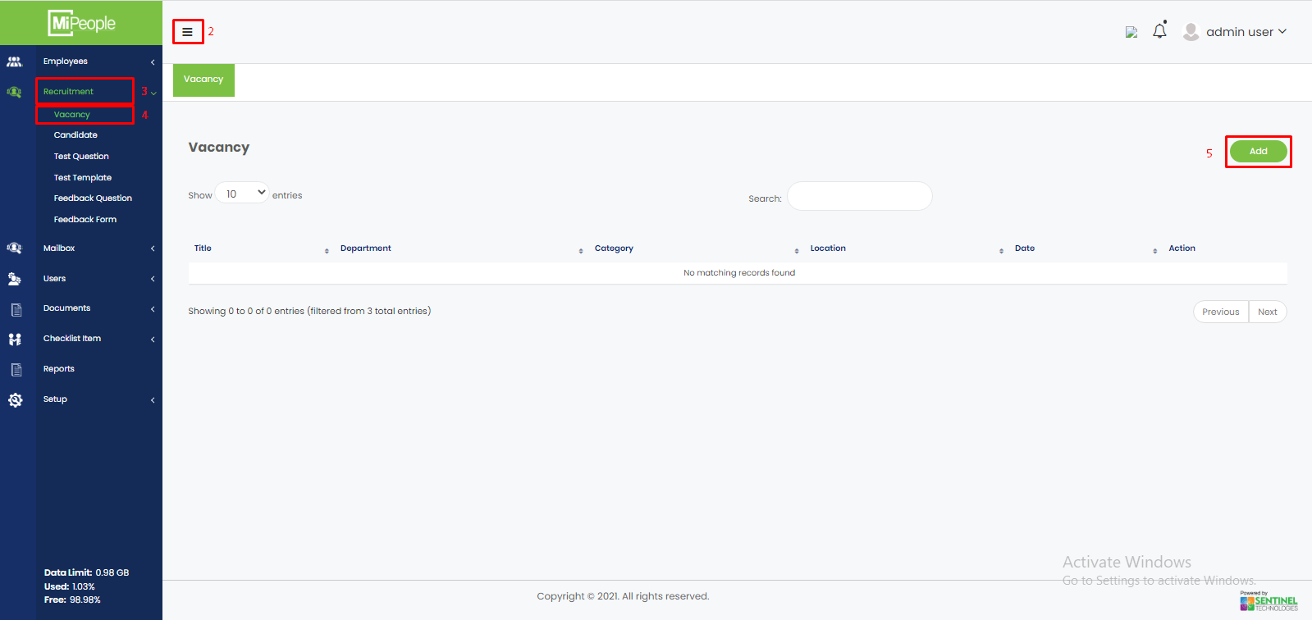

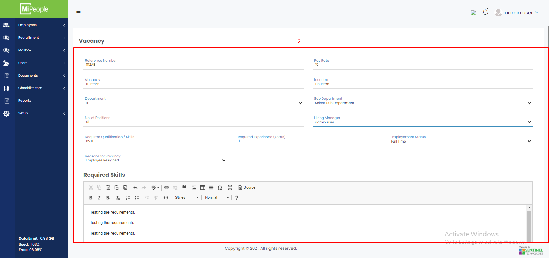

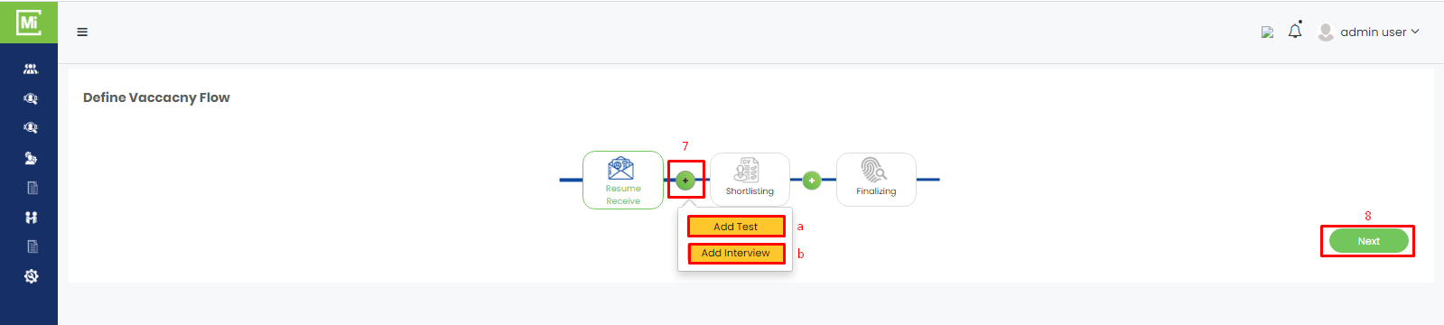

1. Click + button to add in the Vacancy Flow;
   1. Test
   2. Interview
2. Click Next.
3. Open the drop down and Select a User who will receive the Resumes.
4. Click Save and Exit.

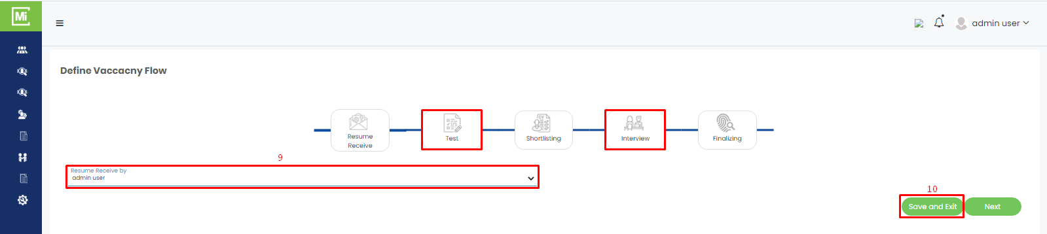

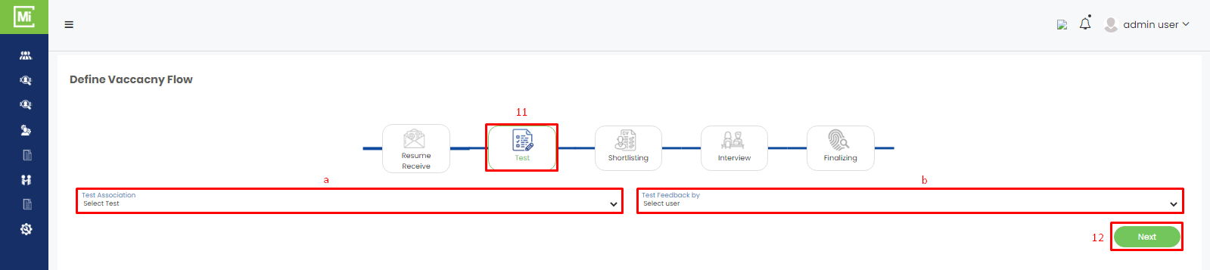

1. Now to define the test;
   1. Select test association from the drop down.
   2. Select the user from the drop down who will give the test feedback.
2. Click Next.
3. Select the person who will shortlist the resumes.
4. Click Next button.
5. Fill in the form for Interview section.
6. Click Next button.

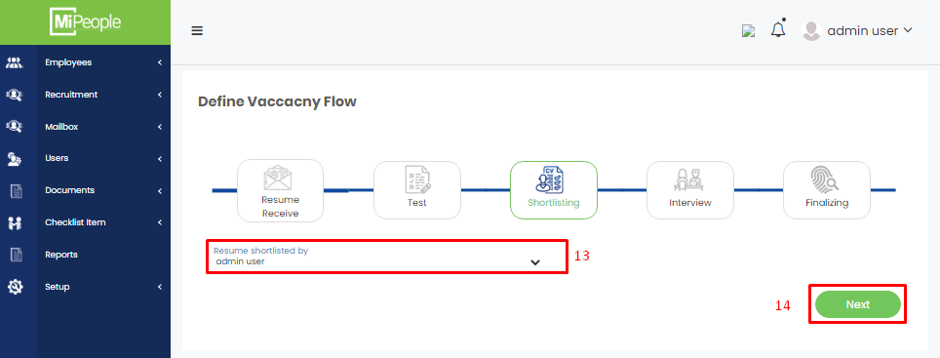

1. Now select the person who will finalize the interview.
2. Click Next.
3. Here your completed vacancy in the table.

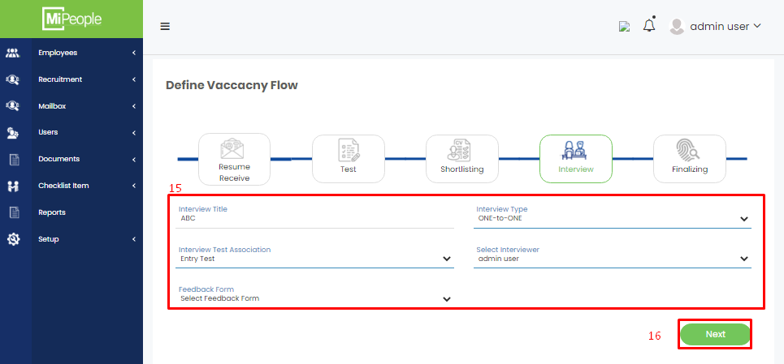

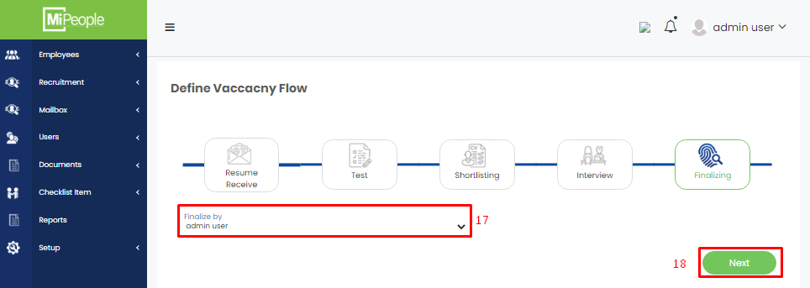

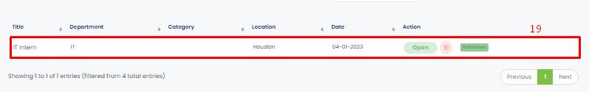

## **Recruitment: Test Question**

1. Go to URL: <https://beta.mipeople.co/login/user_login>
2. Click Side Menu button.
3. Click Recruitment in the Side Menu to open its sub menu.
4. Click Test Question in the sub menu.

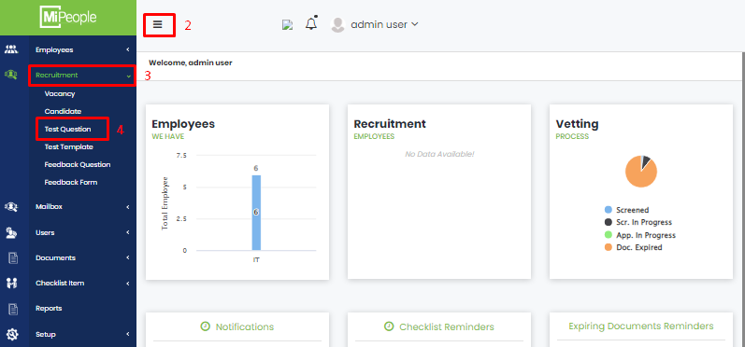

1. Click Add
2. Fill in the fields required to add a new test question.
3. Click Save.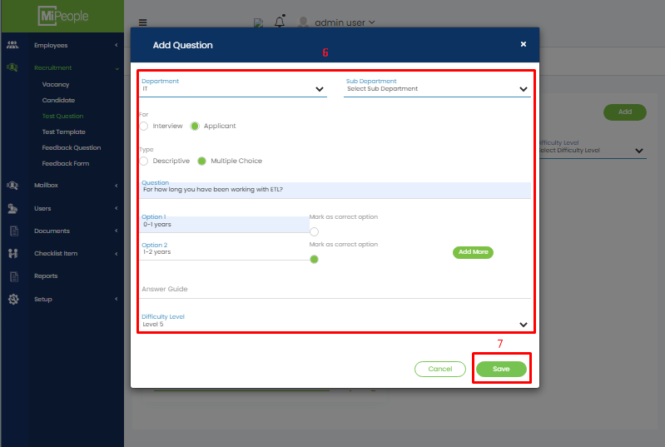

## **Recruitment: Test Template**

1. Go to URL: <https://beta.mipeople.co/login/user_login>
2. Click Side Menu button.
3. Click Recruitment in the Side Menu to open its sub menu.
4. Click Test Template.
5. Click Add button.

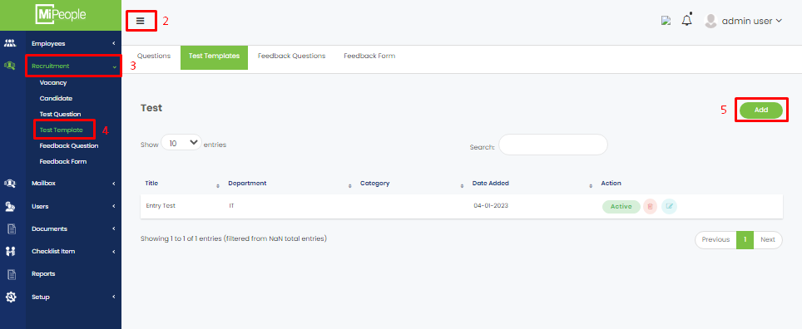

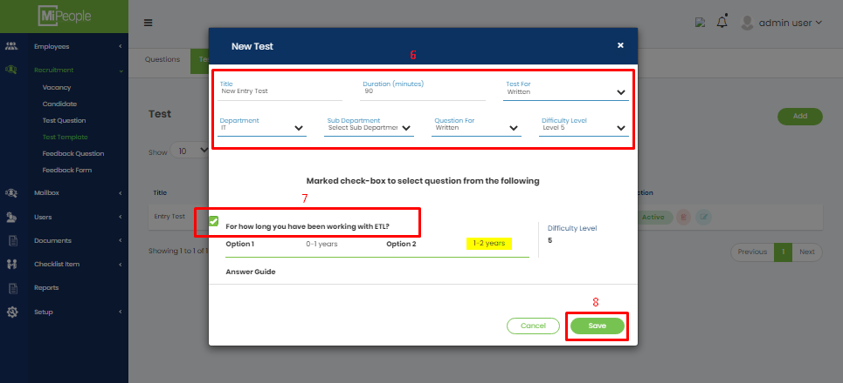

1. Fill in all required fields to create new test template.
2. Check Questions you have created earlier that you want to include in this test.
3. Click Save Button.

## **Recruitment Flow: New Candidate**

1. Go to URL: <https://beta.mipeople.co/login/user_login>
2. Click Side Menu button.
3. Click Recruitment in the Side Menu to open sub menu.
4. Click Candidate in the sub menu.
5. Click Add button.

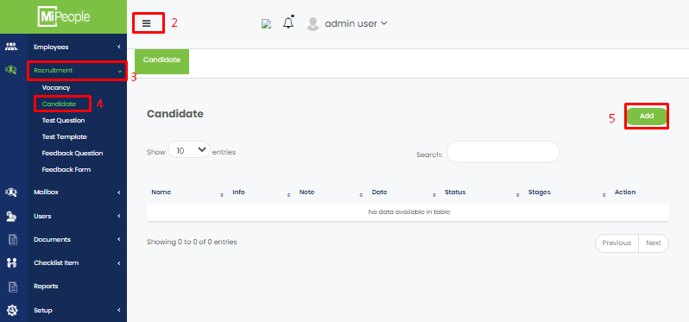

1. Fill in all the fields that are required in adding a new candidate.
2. Click Save.

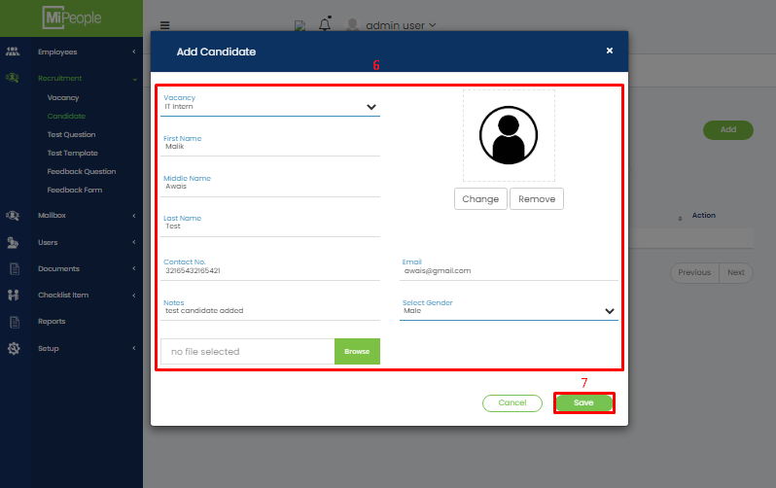

## **Recruitment: Accept Resume from Each Candidate**

1. Go to URL: <https://beta.mipeople.co/login/user_login>
2. Click Side Menu button.
3. Click Recruitment in the Side Menu to open sub menu.
4. Click Candidate in the sub menu.
5. Click on the drop down menu of column Stages and select the option Accept Resume.
6. Click Yes for confirmation.

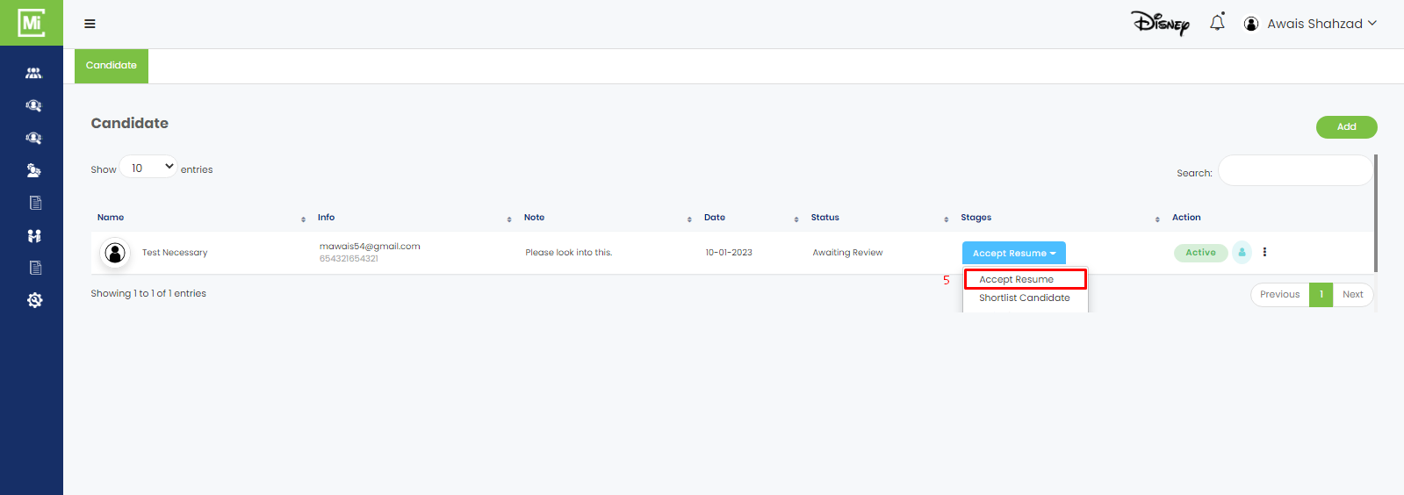

## **Recruitment: Shortlist Candidate**

1. Go to URL: <https://beta.mipeople.co/login/user_login>
2. Click Side Menu button.
3. Click Recruitment in the Side Menu to open sub menu.
4. Click Candidate in the sub menu.
5. Click on the drop down menu of column Stages and select the option Shortlist Candidate.
6. Click Yes for confirmation.

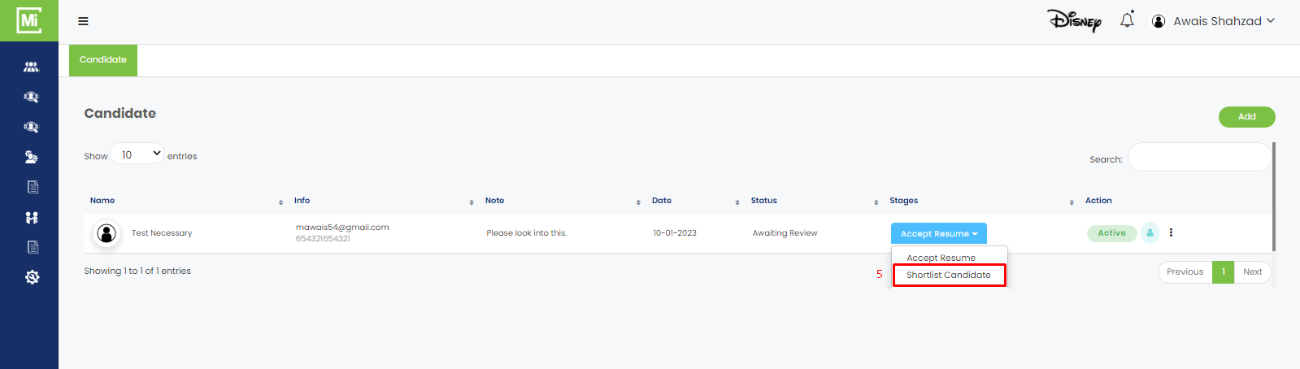

## **Recruitment: Email Test to Candidate**

1. Go to URL: <https://beta.mipeople.co/login/user_login>
2. Click Side Menu button.
3. Click Recruitment in the Side Menu to open sub menu.
4. Click Candidate in the sub menu.
5. Click on the drop down menu of column Stages and select the option Invite for Test.
6. A form will open. Fill in all the required fields.
7. Click Save.
8. An email will be sent on defined email where candidate needs to start the test.

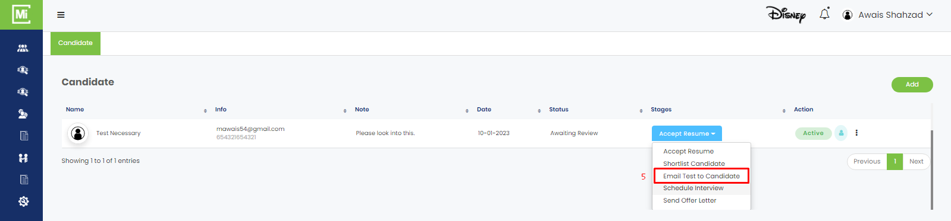

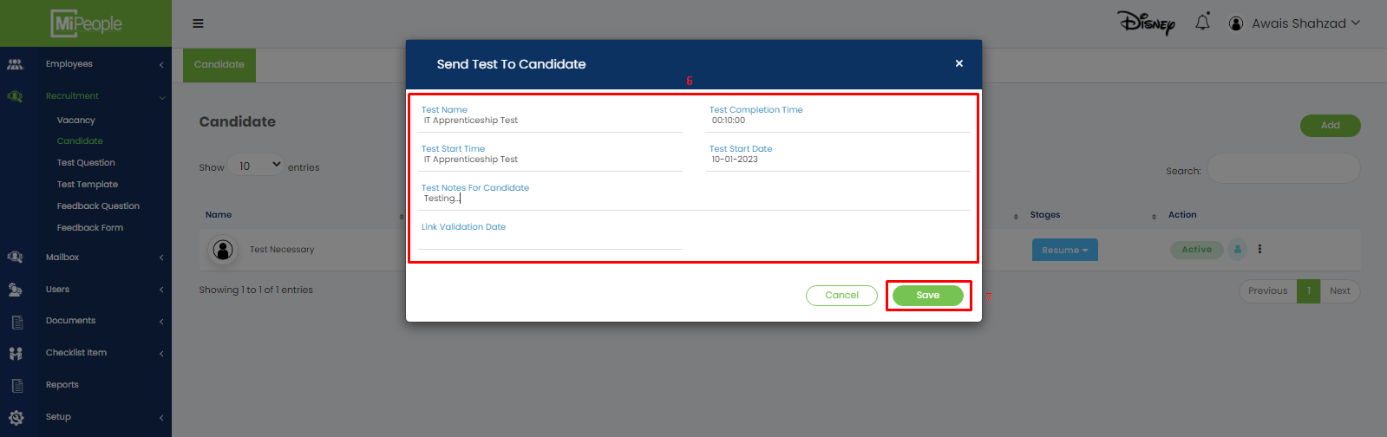

## **Recruitment: Schedule Interview**

1. Go to URL: <https://beta.mipeople.co/login/user_login>
2. Click Side Menu button.
3. Click Recruitment in the Side Menu to open sub menu.
4. Click Candidate in the sub menu.
5. Click on the drop down menu of column Stages and select the option Schedule Interview.
6. A form will open. Fill in all the required fields.
7. Click Schedule.

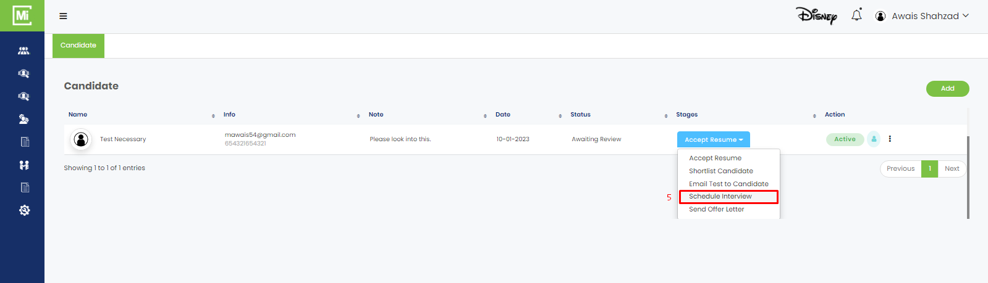

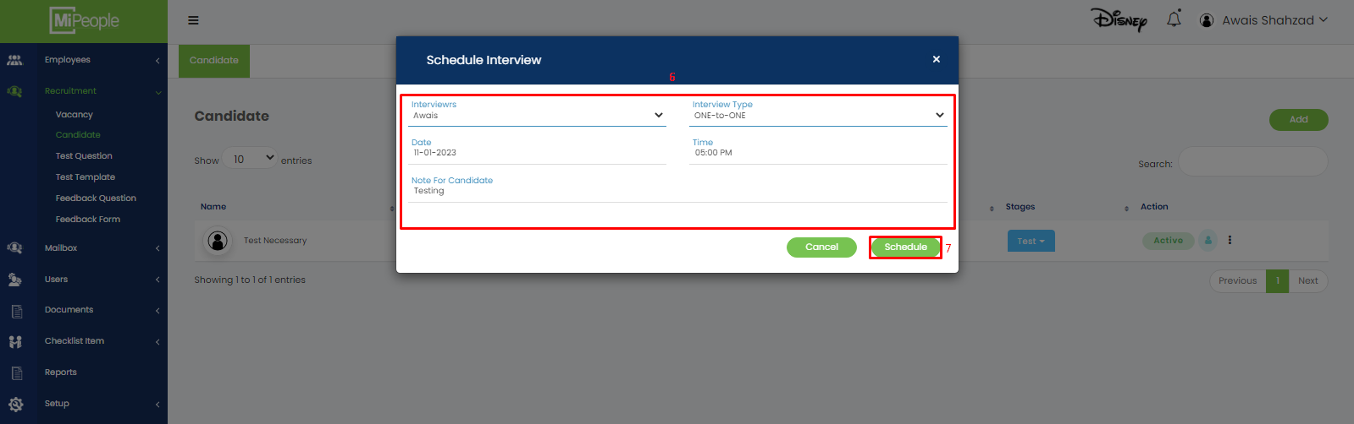

## **Recruitment: Send Offer Letter**

1. Go to URL: <https://beta.mipeople.co/login/user_login>
2. Click Side Menu button.
3. Click Recruitment in the Side Menu to open sub menu.
4. Click Candidate in the sub menu.
5. Click on the drop down menu of column Stages and select the option Send Offer Letter.
6. A form will open. Fill in all the required fields.
7. Click Send.

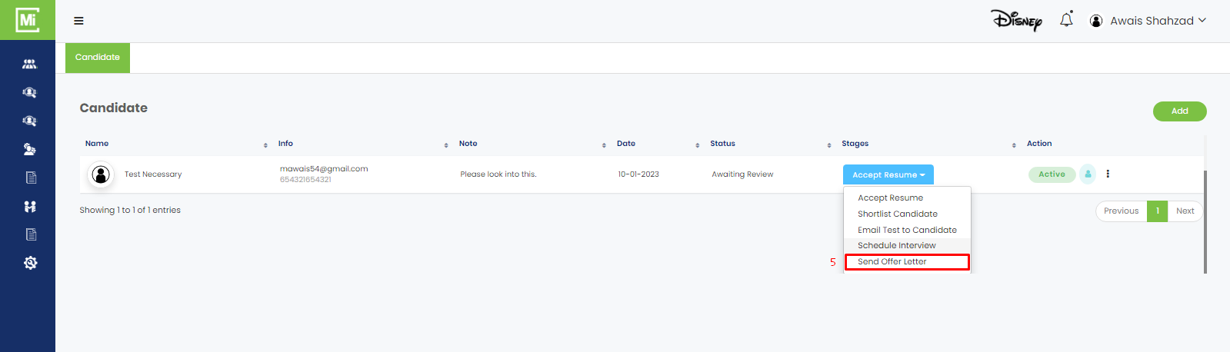

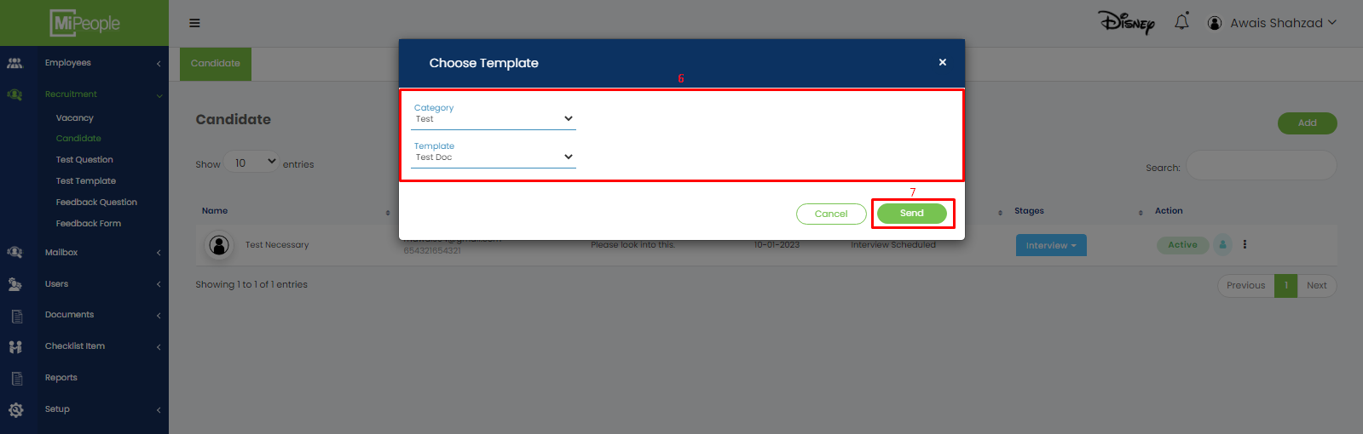

## **Recruitment: Feedback Question**

1. Go to URL: <https://beta.mipeople.co/login/user_login>
2. Click Side Menu button.
3. Click Recruitment in the Side Menu to open sub menu.
4. Click Feedback Question in the sub menu.
5. Click Add New.
6. Add Question form will open. Fill in all the required fields.
7. Click Save.

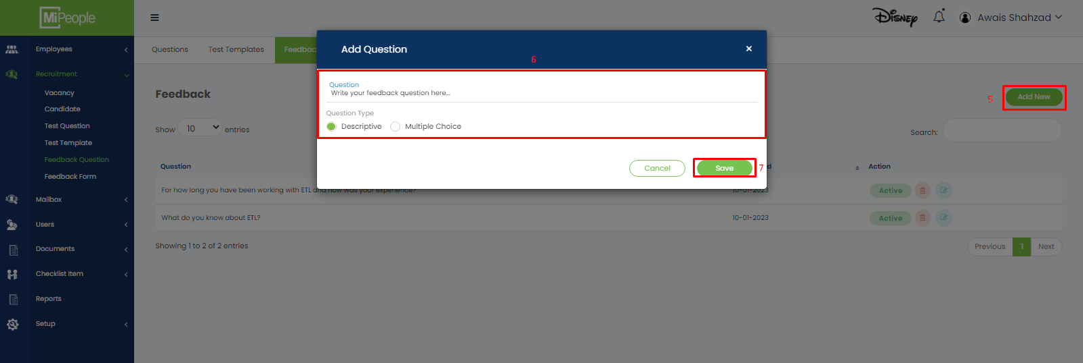

## **Recruitment: Feedback Form**

1. Go to URL: <https://beta.mipeople.co/login/user_login>
2. Click Side Menu button.
3. Click Recruitment in the Side Menu to open sub menu.
4. Click Feedback Form in the sub menu.
5. Click Add New.
6. Add Question form will open. Fill in all the required fields.
7. Click Save.

